NLP — Unit 1 Notes
Introduction and Word-Level Analysis

1. History of NLP
Natural Language Processing started developing in the 1940s.
1940s
- NLP started around the 1940s.
- One of the first recognizable NLP applications was introduced in 1948 at Birkbeck College, London.
1950s
There was a difference of opinion between:
- Linguistics
- Computer Science
In this period, Noam Chomsky developed his work on Syntactic Structures.
Chomsky proposed that:
- Human language has a generative nature.
- Language can be described using rules.
1957 — Generative Grammar
Chomsky introduced the idea of Generative Grammar.
Generative Grammar:
A rule-based description of the syntactic structure of a language.
1960–1980
NLP became increasingly connected with Artificial Intelligence (AI).
⭐ Exam point
NLP started in the 1940s, Chomsky's Generative Grammar was introduced in 1957, and during 1960–1980 NLP became strongly influenced by AI.

2. Introduction to NLP
Humans communicate using natural languages, either through:
- Text
- Speech
For computers to interact naturally with humans, computers need to understand human language.
Definition
Natural Language Processing (NLP) is the technology that enables computers to:
- Learn
- Understand
- Analyze
- Manipulate
- Interpret
human/natural languages.
NLP is a field related to:
- Computer Science
- Human Language
- Artificial Intelligence
Simple definition
NLP is a branch of AI that helps computers understand and process human language.

3. Why NLP is Important
Machines need to interpret human language because many applications require communication between humans and computers.
Examples:
- Chatbots
- Email classification
- Spam filters
- Search engines
- Grammar checkers
- Voice assistants
- Social language translators
NLP systems can take either:
Input → Speech or Written Text
and produce:
Output → Speech or Written Text

4. Main Areas of NLP
NLP is broadly divided into two major areas:
1. Natural Language Understanding — NLU
NLU converts human language into a machine-readable representation.
It helps computers understand and analyze language.
It can extract information such as:
- Keywords
- Emotions
- Relationships
- Semantics/meaning
Example
Human says:
"I am very happy today."
NLU can identify:
- Emotion → Happiness
- Important word → happy
- Time → today

2. Natural Language Generation — NLG
NLG converts computerized data into natural human language.
It acts like a translator:
Machine data → Human-readable language
NLG mainly involves:
- Text planning
- Sentence planning
- Text realization
Text Planning
Decides what information should be communicated.
Sentence Planning
Decides how the information should be organized into sentences.
Text Realization
Converts the planned information into actual natural-language sentences.
Important point
NLU is harder than NLG.

5. What is NLP?
NLP is the process of:
Computer analysis of human-language input → Useful machine representation
The main purpose of NLP is to make computers perform useful and interesting tasks using human language.
NLP also helps humans understand the structure and behavior of human language better.

6. Applications of NLP
Important NLP applications from the PPT:
1. Text-to-Speech
Converts written text into speech and produces natural-sounding voice.
Example: Reading an article aloud.
2. Chatbots
Help computers understand customer questions and respond to them.
3. Urgency Detection
Analyzes language to determine how urgent a request is.
4. Natural Language Understanding
Converts speech/text into understandable information and analyzes its intent.
5. Autocorrect
Detects spelling/text errors and suggests corrections.
6. Sentiment Analysis
Identifies people's opinions or feelings about:
- Products
- Services
- Companies
- Competitors
7. Speech Recognition
Allows applications to understand human voice and determine its meaning.
7. Generic NLP System
NLP is a branch of computer science that focuses on developing systems that allow computers to communicate with humans using everyday language.
NLP is also called:
Computational Linguistics
It also studies how computational methods can help us understand human language.

8. NLP Phases / Levels
NLP processes language at different levels.
The important levels discussed in the PPT are:
- Lexical Analysis
- Syntactic Analysis
- Semantic Analysis
- Discourse Integration
- Pragmatic Analysis
Let's understand each properly.
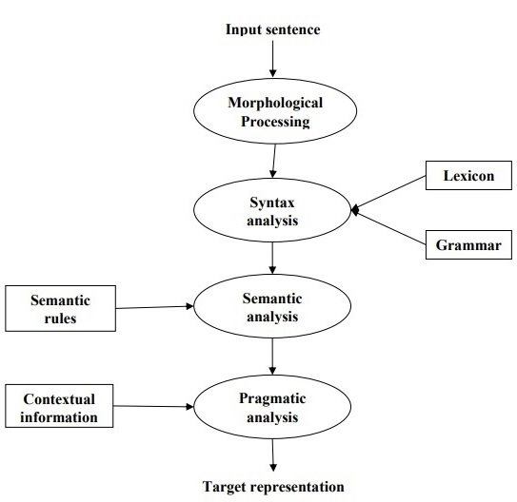

9. NLP Terminology
1. Phonology
Phonology is the study of how sounds are organized systematically in a language.
Example:
Understanding how differeknt sounds form meaningful language patterns.
2. Morphology
Morphology studies the formation and internal structure of words.
Example:
un + friend + ly
3. Morpheme
A morpheme is the smallest/basic unit of meaning in a language.
Example:
cats = cat + s
Here:
- cat → meaning
- s → plural meaning
4. Syntax
Syntax studies the formation and internal structure of sentences.
It determines how words should be arranged.
Example:
Dave wrote the paper.
Correct sentence structure.
5. Semantics
Semantics deals with the meaning of words, phrases and sentences.
6. Pragmatics
Pragmatics deals with understanding language according to the situation/context in which it is used.
The same sentence can have different meanings depending on the situation.
7. Discourse
Discourse deals with how one sentence can affect the interpretation of the next sentence.
8. World Knowledge
World knowledge means the general knowledge about the real world.

10. Lexical Analysis
Meaning
A lexicon is the vocabulary that makes up a language.
Lexical analysis breaks language into smaller units called lexemes.
It can divide text into:
- Paragraphs
- Sentences
- Phrases
- Words
NLP algorithms can also:
- Categorize words into Parts of Speech (POS)
- Break words into morphemes
There are two main types of morphemes:
Free Morphemes
Can work independently as words.
Examples:
- cow
- house
- imagine
Bound Morphemes
Cannot normally exist independently and are attached to other morphemes.
Example:
unimaginable
Break it into:
un + imagine + able
Where:
- un- → negative meaning
- imagine → root/free morpheme
- -able → indicates ability/capability

11. Syntactic Analysis
Syntax describes how words and phrases are arranged to form sentences.
Syntactic analysis checks whether the arrangement follows proper grammar.
Example
"Dave wrote the paper."
This passes syntactic analysis because it is grammatically correct.
Another example in the PPT:
"Agra goes to the Poonam"
is categorized as syntactically incorrect.
Remember
Syntax = Sentence structure / grammar

12. Semantic Analysis
Semantics = Meaning
Semantic analysis tries to understand the literal meaning of words, phrases and sentences.
It focuses on meaning rather than simply checking grammar.
Example
"Manhattan calls out to Dave."
Grammatically, the sentence may be structurally correct.
But semantically it does not make sense because:
- Manhattan is a place.
- A place cannot literally call someone.
Therefore:
Syntactically correct ≠ Semantically meaningful

13. Discourse Integration
Discourse means communication involving multiple sentences or individuals.
Discourse integration uses previous sentences/context to understand the meaning of ambiguous language.
Example
Sentence 1:
"Manhattan speaks to all its people."
Sentence 2:
"It calls out to Dave."
The system uses the first sentence to understand that "It" refers to Manhattan.
Therefore:
Discourse integration uses surrounding/previous sentences to understand meaning.

14. Pragmatic Analysis
Pragmatics deals with the intended meaning of language rather than only the literal meaning.
Pragmatic analysis tries to determine:
"What does the speaker actually intend to communicate?"
It applies rules related to cooperative communication/dialogue.
Example
"Open the door."
Depending on the situation, it can be understood as a request, rather than simply an order.
Easy memory trick
- Syntax → Structure
- Semantics → Meaning
- Discourse → Previous sentences
- Pragmatics → Intended meaning

15. Ambiguity in NLP
Definition
Ambiguity occurs when a word, phrase or sentence has two or more possible interpretations.
This is one of the major difficulties in NLP.
The PPT covers:
- Lexical ambiguity
- Syntactic ambiguity
- Semantic ambiguity

16. Lexical Ambiguity
A word can have multiple meanings or grammatical uses.
Example
The word:
back
can be:
- Noun → back stage
- Adjective → back door
- Adverb → back away
So, one word can be interpreted differently depending on its use.

17. Syntactic Ambiguity
A sentence can have multiple possible grammatical structures/parse trees.
Example
"I heard his cell phone ring in my office."
The phrase:
"in my office"
can have different interpretations.
It may modify:
- The noun/cell phone
- The verb/ringing event
Thus, the sentence has multiple possible syntactic structures.

18. Semantic Ambiguity
Semantic ambiguity occurs when a sentence can have different interpretations of meaning.
For the previous example:
"I heard his cell phone ring in my office."
It could mean:
- I was physically present in my office.
- The cell phone was in my office.
Thus, the sentence has different possible meanings.

19. Corpus in NLP
Definition
A corpus is a large collection of text or language data written/spoken in real-life language.
Examples of corpus sources:
- Digital text
- Audio transcripts
- Scanned documents
Plural of corpus:
Corpora
Corpora help researchers and NLP systems understand how language is actually used in real life.

20. Why Corpus is Important in NLP
A corpus is a fundamental resource for NLP.
It can contain:
- Text
- Audio
- Documents
- Voices
- One or more languages
1. Training Machine Learning Models
Corpora are used to train NLP models for:
- Sentiment analysis
- Text classification
- Machine translation
- Speech recognition
Large amounts of data help models learn:
- Patterns
- Relationships
- Language complexity
2. Language Understanding
Corpora help understand:
- Grammar
- Vocabulary
- Language structure
- Word usage
- Phrase usage
3. Rule-Based Systems
Linguists and NLP experts use corpora to develop and test language rules.
These rules can be used for:
- POS tagging
- Grammatical processing
- Named Entity Recognition
4. Lexicon and Semantics
Corpora help create and expand dictionaries/lexicons.
They can help identify:
- Synonyms
- Antonyms
- Word relationships
5. Statistical Analysis
Corpora provide information about:
- Word frequency
- Co-occurrence patterns
- Statistical language characteristics
6. Domain-Specific Knowledge
Corpora can be created for particular fields.
Examples:
- Legal documents
- Medical records
- Industry-specific chatbots

21. Examples of Corpora
1. Penn Treebank
Type: Corpus with linguistic annotations
It contains sentences processed from sources such as the Wall Street Journal.
Used for:
- Developing analyzers
- Evaluating analyzers
- Grammatical analysis
- POS annotations

2. WordNet
Type: Lexical resource/database
WordNet organizes words into synsets.
A synset is a set of synonymous words.
It represents semantic relationships between words.
Applications include:
- Information retrieval
- Word-sense identification

3. VerbNet
Type: Lexical Resource
VerbNet focuses on verbs.
It groups verbs into classes according to:
- Grammatical behavior
- Semantic behavior
- Argument structure

4. GloVe
Full form: Global Vectors for Word Representation
Type: Pre-trained word vectors
GloVe provides word embeddings that represent semantic relationships between words.
Applications:
- Sentiment analysis
- Word similarity
- Improving NLP model performance

22. Morphology Analysis
Definition
Morphology is the study of how words are formed and how they are built from smaller meaningful parts.
Morphological analysis studies the internal structure of words.
The smallest meaningful elements are called morphemes.
Examples
played = play + ed
cats = cat + s
unfriendly = un + friend + ly

23. Stems and Affixes
There are two important components:
1. Stem
The main/base part of the word.
Examples:
- play
- cat
- friend
2. Affixes
Additional parts attached to a stem.
Examples:
- -ed
- -s
- un-
- -ly

24. Types of Affixes
Prefix
A prefix comes before the stem.
Example:
un + friend
Here un- is the prefix.
Suffix
A suffix comes after the stem.
Examples:
play + ed
cat + s
friend + ly
Morphological information is useful in NLP applications such as:
- Machine Translation
- Natural Language Understanding
- Semantic Role Labeling

25. Inflectional Morphology
Definition
Inflectional morphology adds grammatical information to a word.
It can express:
- Number
- Tense
- Agreement
- Case
The important point is:
Inflection usually does not create a completely new word or change its grammatical category.
It creates different forms of the same word.
Example
bake → baking
The basic meaning remains related to cooking with an oven.
-ing changes the grammatical form.
Examples
Category | Stem | Affix | Result
Noun | word | — | word
Noun | box | -s | boxes/words examples in PPT
Noun | box | -es | boxes
Verb | treat | -s | treats
Verb | treat | -ing | treating
Verb | treat | -ed | treated
Key idea
Inflection = different grammatical form of the same word.

26. Derivational Morphology
Derivational morphemes can create new words.
Unlike inflectional morphology, derivation can change the grammatical category of the word.
Examples
Caramel (noun) + ize → caramelize (verb)
Decorate (verb) + ive → decorative (adjective)
Flour (noun) + less → flourless (adjective)
Important Difference
When a derivational morpheme is added:
- A new word may be created.
- Meaning may change.
- Word class may change.
When an inflectional morpheme is added:
- The word remains essentially the same word.
- Its form changes according to grammatical requirements.

⭐ Inflectional vs Derivational Morphology
Inflectional | Derivational
Creates different form of same word | Creates a new word
Usually does not change word class | Can change word class
Gives grammatical information | Changes/creates meaning
Example: treat → treated | Example: decorate → decorative
Shows tense, number, etc. | Forms new vocabulary
Inflection = grammar
Derivation = new word

27. Text Analysis and Text Preprocessing
In machine learning, data cleaning/preprocessing is extremely important.
Text is one of the most unstructured forms of data.
Human language is complex because it contains:
- Different writing styles
- Punctuation
- Emotions
- Different cases
- Noise
- Variations in words
Applications like:
- Alexa
- Siri
- Google Assistant
need NLP techniques to process human language.
Before the final response is generated, a lot of text preprocessing may happen.

28. Text Preprocessing
Definition
Text preprocessing is the process of cleaning text data and preparing it for a machine learning/NLP model.
Raw text can contain noise such as:
- Punctuation
- Different uppercase/lowercase forms
- Unnecessary words
- Digits
- Special characters
- Contractions

29. Libraries Used in NLP
Important libraries mentioned in the PPT:
1. Regular Expression — re
Used mainly for:
- Text cleaning
- Pattern matching
2. NLTK
Natural Language Toolkit
Used for many NLP tasks such as:
- Stopword removal
- Stemming
3. spaCy
A popular NLP library used for processing natural language.

30. Text Preprocessing Techniques
- Understanding problem statement
- Load data
- Expand contractions
- Convert to lowercase
- Remove punctuation
- Remove words/digits containing digits
- Remove stopwords
- Stemming and lemmatization
- Tokenization

31. Expand Contractions
A contraction is a shortened form of words.
Examples:
don't → do not
aren't → are not
We expand contractions because the full form can be easier for NLP systems to analyze.
A contraction dictionary can be created or obtained, and Python's re module can be used to map contractions.

32. Lowercase Conversion
Computers may treat uppercase and lowercase versions as different.
Example:
Ball
and
ball
may be treated as different tokens.
Therefore, text is often converted into lowercase.
Example:
I LOVE NLP
↓
i love nlp
This reduces unnecessary differences in the text.

33. Remove Punctuation
Punctuation can be removed during preprocessing when it is not useful for the task.
The PPT mentions the common punctuation characters:
!"#$%&'()*+,-./:;<=>?@[\]^_`{|}~
Python's string module and regular expressions can be used to remove punctuation.

34. Remove Words/Digits Containing Digits
Sometimes words contain a combination of letters and numbers.
Examples:
- game57
- game5ts7
These can be difficult for some NLP processing tasks.
Therefore, such words may be:
- Removed
- Replaced with an empty string
Regular expressions can be used for this purpose.

35. Remove Stopwords
Definition
Stopwords are very common words that usually provide little useful information for certain NLP tasks.
Examples:
- they
- there
- this
- where
The PPT mentions that NLTK provides approximately 180 stopwords.
Additional stopwords can also be added to the set using the add() method.
Example
Original:
"This is a good movie."
After stopword removal:
"good movie"
⚠️ Exam point: Stopword removal is task-dependent. Some tasks may need words such as "not".

36. Stemming
Definition
Stemming reduces words toward their root/stem by removing prefixes or suffixes.
Examples:
- running → run
- runs → run
- runed → run
The basic idea is to remove endings such as:
- ing
- s
- es
NLTK can be used for stemming.
Algorithms
Important stemming algorithms mentioned:
- Porter Stemmer
- Snowball Stemmer
Porter Stemmer is widely used and is available in NLTK.
The PPT notes that stemming is generally not preferred for production because it can sometimes produce unwanted/non-correct stems.

37. Lemmatization
Lemmatization is similar to stemming because it reduces words to a base/root form.
But the method is different.
Definition
Lemmatization systematically reduces a word to its lemma using a language dictionary.
It tries to produce a proper meaningful base word rather than simply cutting characters.
Main difference
Stemming → cuts/removes word parts
Lemmatization → uses linguistic knowledge/dictionary

38. Tokenization
Definition
Tokenization is the process of breaking text into smaller units called tokens.
Tokens can be:
- Words
- Numbers
- Punctuation marks
Example
Sentence:
"NLP is interesting."
Tokens:
NLP
is
interesting
.
Why do we need tokenization?
It allows us to:
- Break text into manageable units
- Count word frequencies
- Build NLP models based on those units

39. Bag of Words — BoW
Bag of Words is an NLP technique for representing text numerically.
Why do we need BoW?
Machine learning algorithms generally work with numbers, not raw text.
Therefore:
Text → Numerical representation → ML algorithm
BoW converts text into a representation based mainly on word occurrence/frequency.
It keeps the count of occurrences of words in the text.

40. BoW Example
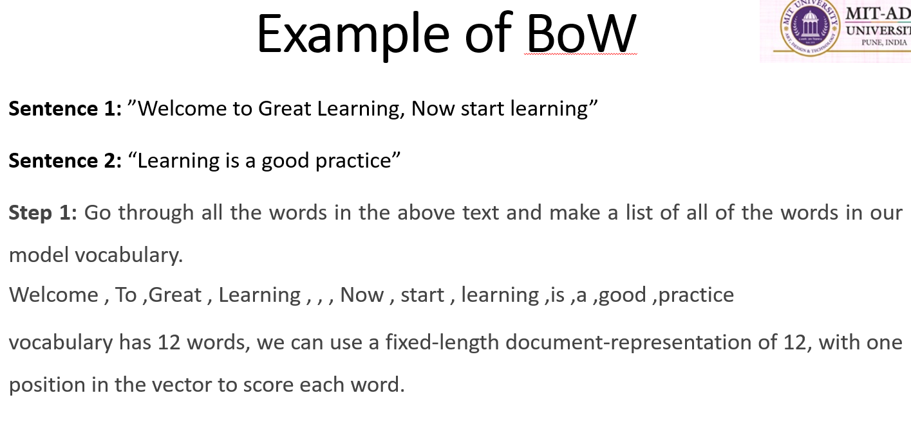
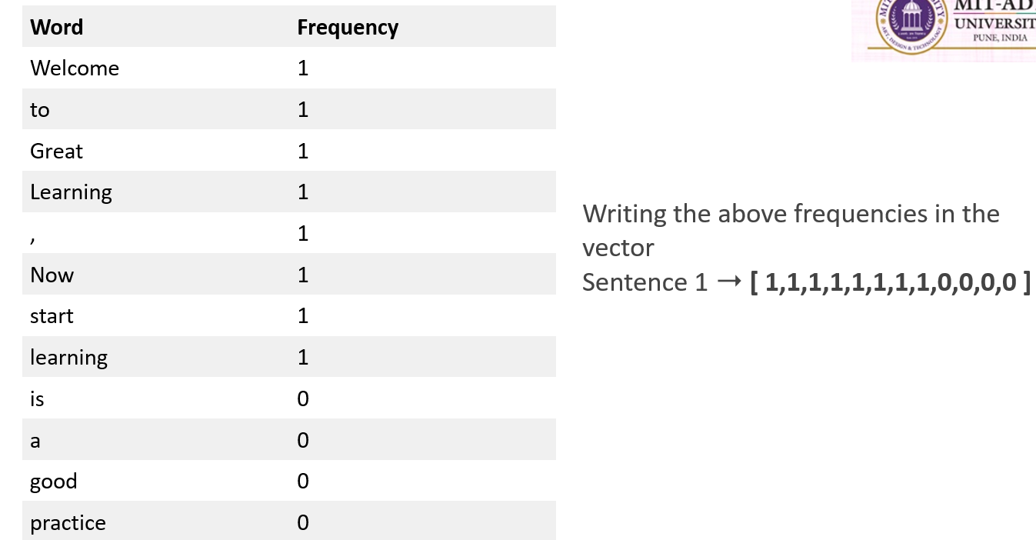
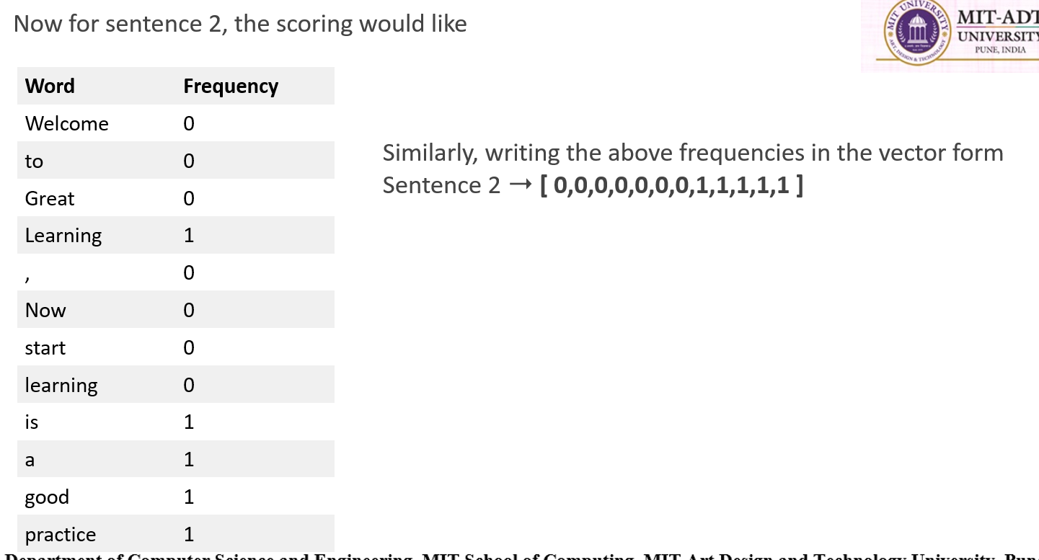

41. BoW with Preprocessing
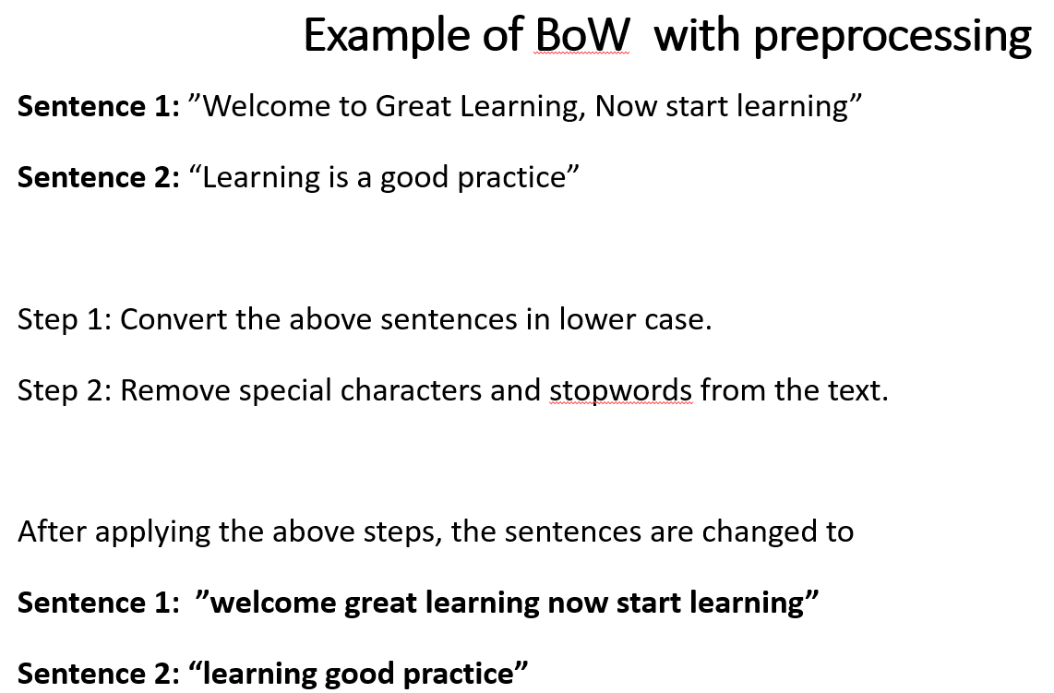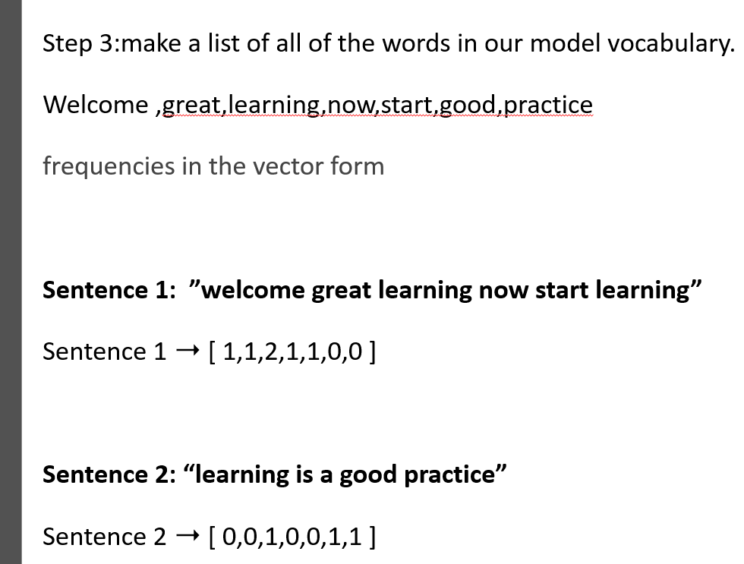

42. BoW Example — Movie Reviews
Three reviews:
Review 1:
This movie is very scary and long
Review 2:
This movie is not scary and is slow
Review 3:
This movie is spooky and good
Vocabulary contains 11 words:
This, movie, is, very, scary, and, long, not, slow, spooky, good
Vectors:
Review 1
[1 1 1 1 1 1 1 0 0 0 0]
Review 2
[1 1 2 0 0 1 1 0 1 0 0]
Review 3
[1 1 1 0 0 0 1 0 0 1 1]

43. Drawbacks of Bag of Words
BoW has several limitations.
1. Vocabulary Size Increases
If new sentences contain new words:
Vocabulary increases → Vector length increases
This can create very large vectors.
2. Many Zeros
The vectors can contain a large number of 0s.
This creates a sparse representation.
3. No Grammar Information
BoW does not preserve sentence grammar.
4. No Word Order
BoW does not retain the ordering of words.
For example:
"Dog bites man"
and
"Man bites dog"
may have similar word-frequency representations even though their meanings are different.
⭐ Remember
BoW tells us WHAT words occur, but not WHERE they occur or how they are grammatically related.

44. N-Gram Language Model
Language Modeling
Language modeling determines the probability of a sequence of words.
It is an important NLP task.
Applications include:
- Speech recognition
- Spam filtering
- Other language-processing applications
N-Gram
An N-gram is a contiguous sequence of N items from text or speech.
Items can be:
- Words
- Characters
- Other tokens

45. Types of N-Grams
Consider:
"I love reading history books and watching documentaries."
1. Unigram
N = 1
One-word sequences.
Examples:
- I
- love
- reading
- history
- books
- and
- watching
- documentaries

2. Bigram
N = 2
Two-word sequences.
Examples:
- I love
- love reading
- history books
- books and
- and watching

3. Trigram
N = 3
Three-word sequences.
Examples:
- I love reading
- love reading history
- history books and
- and watching documentaries

46. How N-Gram Language Models Work
An N-gram language model predicts the probability of an N-gram within a sequence of words.
It can predict:
P(w | h)
where:
- w = current word
- h = history of previous words
- History contains N − 1 words
So the model asks:
"Given the previous words, how likely is this next word?"

47. Advantages of N-Grams
1. Simplicity
N-grams are relatively easy to understand and implement.
2. Low Memory Usage
They require comparatively less memory than more complex language models.

48. Limitations of N-Grams
1. Limited Context
An N-gram only looks at a fixed number of previous words.
It cannot properly capture long-range dependencies.
2. Sparsity
As N increases:
Possible N-grams increase rapidly → Data becomes sparse
This also increases computational requirements.

49. Regular Expression
A Regular Expression (Regex) is a pattern used for searching and matching text.
It is a language/notation used to describe sets of strings.
Regex is especially useful when:
- We know the pattern we want to find.
- We have a large corpus/text to search.
A regex search returns text that matches the specified pattern.

50. Applications of Regular Expressions
Regex is used in:
- Data preprocessing
- Rule-based information mining
- Pattern matching
- Text feature engineering
- Web scraping
- Data extraction

51. Regex Character Sets
[abc]
Matches either:
- a
- b
- c
It does not match the complete string abc.

[a-z]
Matches any lowercase alphabet from:
a to z

[A-Z]
Matches uppercase alphabets from:
A to Z

[a\-p]
Matches:
- a

- p
The \ escapes -, so the hyphen is treated as a character.

[-z]
Matches:
- -
- z

[a-z0-9]
Matches:
- lowercase letters a–z
- digits 0–9

52. Regular Expression Examples
(0 + 10*)
Represents strings such as:
0, 1, 10, 100, 1000, ...
(0*10*)
Examples:
1, 01, 10, 010, 0010, ...
(0 + ε)(1 + ε)
Produces:
ε, 0, 1, 01
Here:
ε = empty/null string

(a+b)*
Represents strings made from a and b of any length.
Examples:
ε, a, b, aa, ab, bb, ba, aaa...

(a+b)*abb
Represents strings of a and b that end with:
abb
Examples:
abb
aabb
babb
aaabb
ababb

(11)*
Represents strings containing an even number of 1s.
Examples:
ε
11
1111
111111

(aa)*(bb)*b
Represents strings containing:
- Even number of as
- Followed by odd number of bs
Examples:
b
aab
aabbb
aabbbbb
aaaab

(aa + ab + ba + bb)*
Produces strings of a and b having even length, generated by combinations of:
- aa
- ab
- ba
- bb

53. Finite Automata
Regular expressions are not only useful for searching text.
A regular expression can describe a:
Finite-State Automaton (FSA)
Finite-state automata can be:
- Deterministic Finite Automata (DFA)
- Non-deterministic Finite Automata (NFA)
They decide whether a given string should be:
- Accepted
- Rejected
A transducer can additionally produce an output for an input.
Important relationship:
Every regular expression can be implemented as an FSA.
And:
Every finite-state automaton can be represented using a regular expression.
Both regular expressions and finite-state automata describe regular languages.

54. Finite Automata in NLP
Finite-state machines are useful in many NLP tasks.
The PPT specifically discusses:
1. Finite State Transducer
An FST is a finite-state machine having two memory/input-output tapes.
It maps between two sets of symbols.
In simple words:
FST takes an input sequence and produces a corresponding output sequence.

55. Language Recognizer
A language recognizer determines whether a particular input belongs to a particular language/pattern.
Examples of NLP tasks requiring language recognition:
- Spell checking
- Morphological analysis
- Language identification
Finite-state machines are useful as language recognizers.

56. NFA for Words
The PPT gives an example of an NFA for the words "boy" and "bat".
The idea is:
- Construct an NFA for individual words.
- Different NFAs can be combined.
- The combined machine can be used for tasks such as:
  - Spell checking
  - Dictionary compilation

57. NFA for Morphological Variations
Separate NFAs can be constructed for different categories of words.
For example:
Noun NFA
Can recognize:
- Noun
- Plural noun
- Other morphological variations
Verb NFA
Can recognize:
- Verb
- Different verb forms
These individual NFAs can then be combined through transitions.
This helps recognize words and their morphological variations.

58. Challenges in NLP
NLP is difficult because human language is complex and highly variable.
The PPT identifies several challenges.

1. Contextual Words, Phrases and Homonyms
Homonyms
Homonyms are words that can have the same pronunciation but different meanings/definitions.
They create problems in:
- Question answering
- Speech-to-text
Example mentioned in the PPT:
their and there
The system must determine which word is intended based on context.

59. Ambiguity
As discussed earlier, ambiguity means:
A word, phrase or sentence has two or more possible interpretations.
This makes it difficult for machines to understand exactly what a person means.

60. Errors in Text and Speech
Text may contain:
- Misspelled words
- Incorrectly used words
- Grammar mistakes
- Speech recognition errors
Autocorrect and grammar correction systems can handle common mistakes, but they may not always understand the writer's actual intention.

61. Development Time and Resource Requirements
NLP project development depends on several factors:
- Complexity of the task
- Size of data
- Quality of data
- Availability of tools/libraries
- Expertise of the development team
Therefore, large and complex NLP systems can require significant time and resources.

62. Real-Time Processing and Responsiveness
Some NLP applications must work in real time.
Examples:
- Digital assistants
- Real-time translation
The challenge is to:
Reduce latency while maintaining accuracy.
In other words, the system must be both:
Fast + Accurate

63. Data Quality and Availability
The performance of an NLP model strongly depends on:
- Quality of training data
- Quantity of training data
Poor-quality or insufficient data can reduce the effectiveness of the NLP model.

64. Integration with Existing IT Infrastructure
Adding NLP to an existing organization's IT infrastructure requires:
- Careful planning
- Proper implementation
- Integration with existing systems
Successful integration can help businesses:
- Process large volumes of language data
- Understand language data
- Improve decision-making
- Improve customer experience
- Improve operational efficiency
NLP vs NLU vs NLG
NLP | NLU | NLG
Broad field | Part of NLP | Part of NLP
Processes human language | Understands language | Generates language
Includes understanding + generation | Human language → machine representation | Machine data → human language

Syntax vs Semantics vs Pragmatics vs Discourse
Concept | Meaning
Syntax | Structure/grammar
Semantics | Literal meaning
Discourse | Meaning using previous/next sentences
Pragmatics | Intended meaning according to situation
Memory trick:
S → Structure
S → Semantics/Meaning
D → Discourse/context across sentences
P → Practical/intended meaning

🔥 Stemming vs Lemmatization
Stemming | Lemmatization
Removes prefixes/suffixes | Uses language dictionary
Simple approach | More systematic
Can produce incorrect/non-word stems | Produces meaningful lemma
Faster | Usually more computationally involved
Example: studies → studi may occur | studies → study

🔥 Inflectional vs Derivational
Inflectional | Derivational
Same word | New word
Grammatical information | New meaning/word
Usually doesn't change POS | Can change POS
Tense, number, etc. | New vocabulary
treat → treated | decorate → decorative

🔥 BoW vs N-Gram
Bag of Words | N-Gram
Counts words | Captures sequences of words
Ignores word order | Maintains local word order
Simple representation | Represents word sequences
Does not capture context well | Captures limited context
Can create sparse vectors | Can also suffer from sparsity

🔥 Free vs Bound Morphemes
Free Morpheme | Bound Morpheme
Can exist independently | Cannot normally exist independently
cat | -s
house | un-
imagine | -able

🔥 Regex vs Finite Automata
Regular Expression | Finite Automaton
Pattern notation | Machine/model
Describes regular language | Recognizes regular language
Used for pattern matching | Accepts/rejects strings
Can be implemented as FSA | Can be represented using regex

